SHULL SCIENCE · JAMES A. GARFIELD LOCAL SCHOOLS
UNIT 2 TEST C: WRITTEN
UNIT 2 TEST · DAY 2 · WRITTEN · VERSION C · TEACHER KEY
NAME | DATE | PERIOD | SCORE / 14

You may use a periodic table. Write every configuration in order of filling. In the orbital diagram, each electron gets one arrow.

Part 1 Longhand configurations | 8 points

Number 1 also needs its orbital diagram and the number of half-filled orbitals.
1  4 pts | 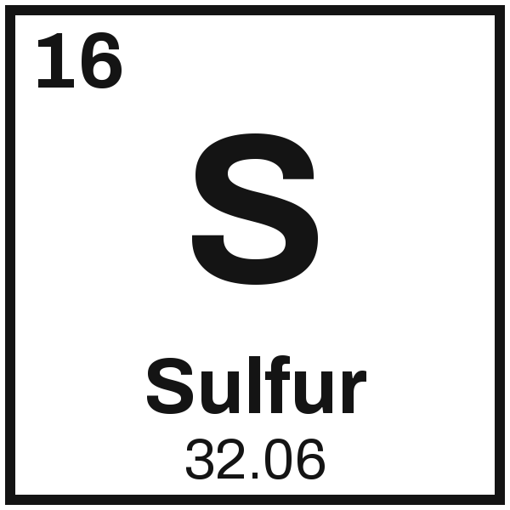 | Configuration 1s² 2s² 2p⁶ 3s² 3p⁴ Half-filled orbitals 2
1  4 pts |  | Orbital diagram
  1s | ↑↓ | 2s | ↑↓ | 2p | ↑↓ | ↑↓ | ↑↓ | 3s | ↑↓ | 3p | ↑↓ | ↑ | ↑

2  2 pts | 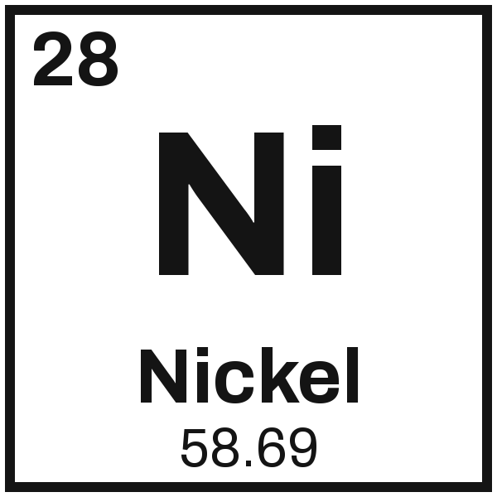 | Configuration 1s² 2s² 2p⁶ 3s² 3p⁶ 4s² 3d⁸

3  2 pts | 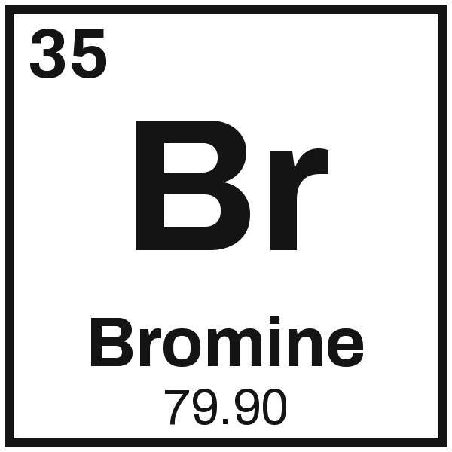 | Configuration 1s² 2s² 2p⁶ 3s² 3p⁶ 4s² 3d¹⁰ 4p⁵

1 is 4 pts, configuration 2, diagram 1, half-filled count 1. 2 and 3 are 2 pts each, 1 off for one wrong sublevel.

Part 2 Noble-gas shorthand | 6 points

4  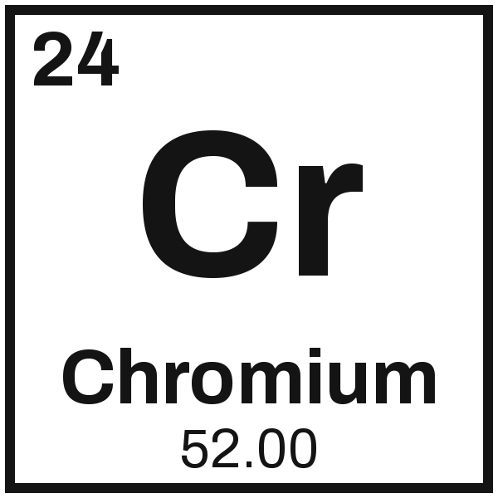 | 5  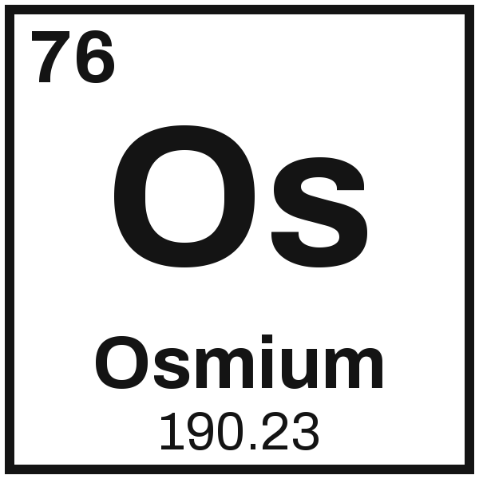 | 6  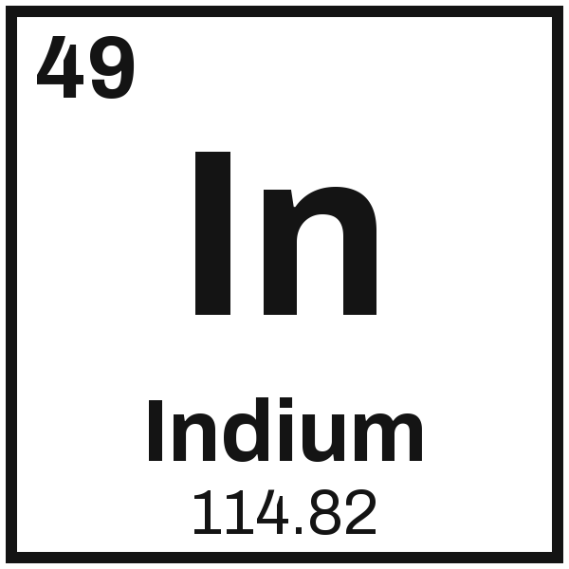
  [Ar] 4s¹ 3d⁵
  [Xe] 6s² 4f¹⁴ 5d⁶
  [Kr] 5s² 4d¹⁰ 5p¹

2 pts each, noble-gas core 1 and the rest in order 1. Chromium is the exception, so the predicted [Ar] 4s² 3d⁴ earns 1.

